**Contents**

All About Me 2

Important People 3



My journey so far 4



How others describe me 5



The best way to communicate with me 6

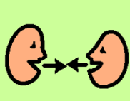

Things I like doing 7



My dreams 8



What is important to me 9

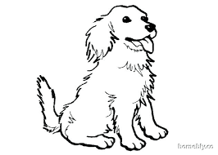

The best ways to help me 10



# All About Me

# Important People



# My journey so far



# How others describe me



# The best way to communicate with me

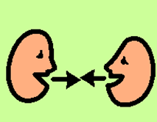

# Things I like doing



# My dreams



# What is important to me



# The best ways to help me

